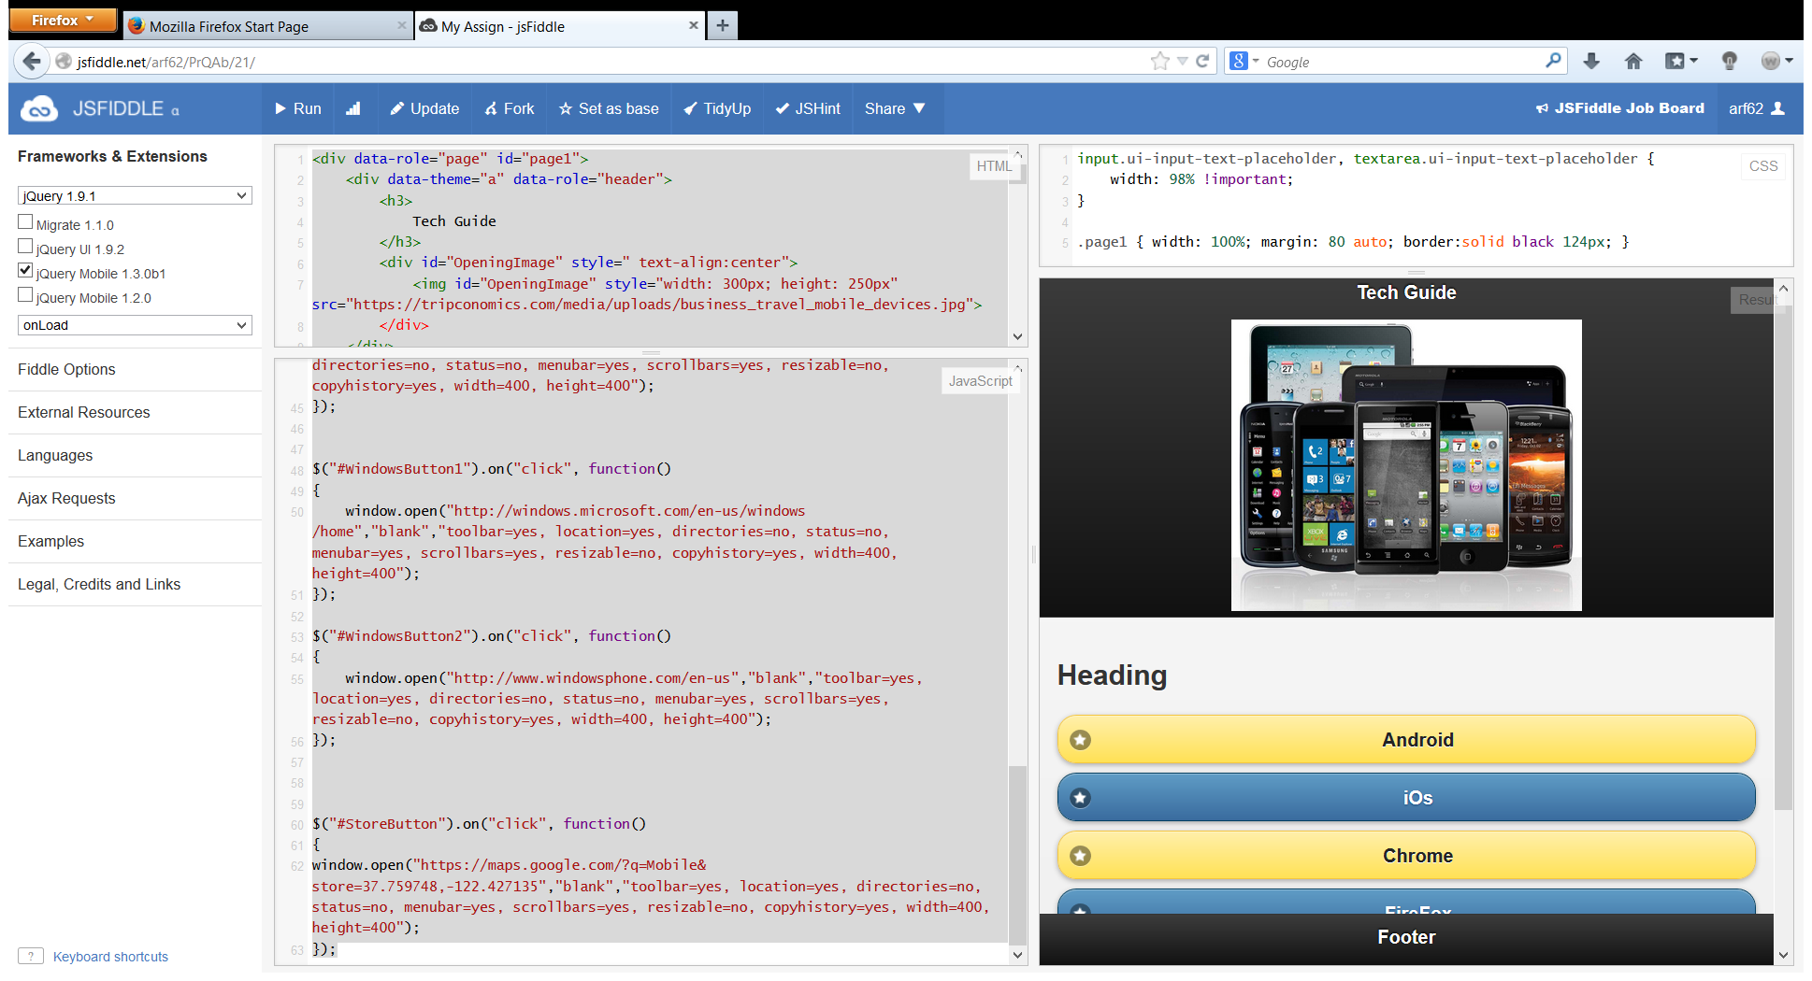

The above screen shot shows the first page or the welcome screen of my first ASE assignment. I like to call it the “Tech Guide ”. This app is an effort to bring the latest news and videos and updates about all the hot and happening technologies into one place.

The app provides details about the Android platform and the phones which support it, the iOs platform and the iphone , the Chrome OS platform, the Firefox Os platform and the windows platform and the windows phones.

Also the unique “Find A store ” option dynamically find’s out the user’s location and based on that returns a google map indicating the different stores in and around the user’s location where the user can buy some or all of these gadgets.

Jsfiddle ink to my project: http://jsfiddle.net/arf62/PrQAb/25/

The following screen shots will show the look and feel of all the things I have mentioned above.

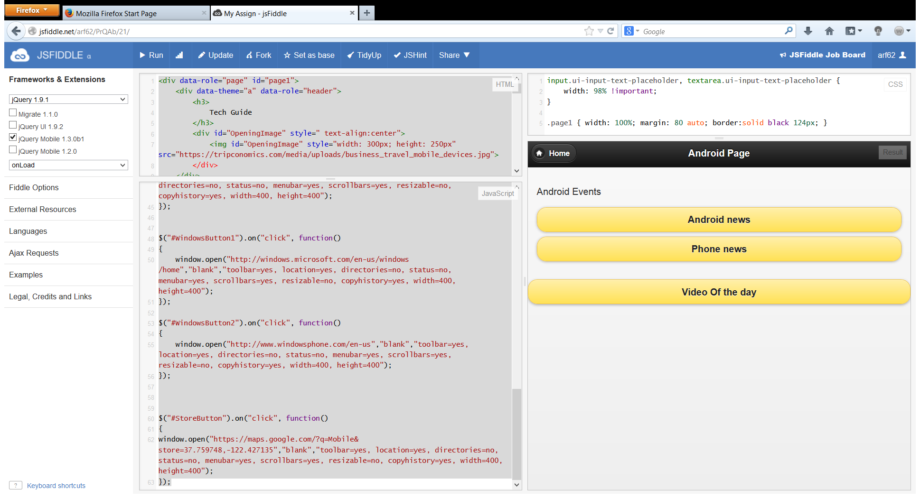

The above screen appears when the user clicks on the Android button in the welcome screen.

It shows all the details about android technology.

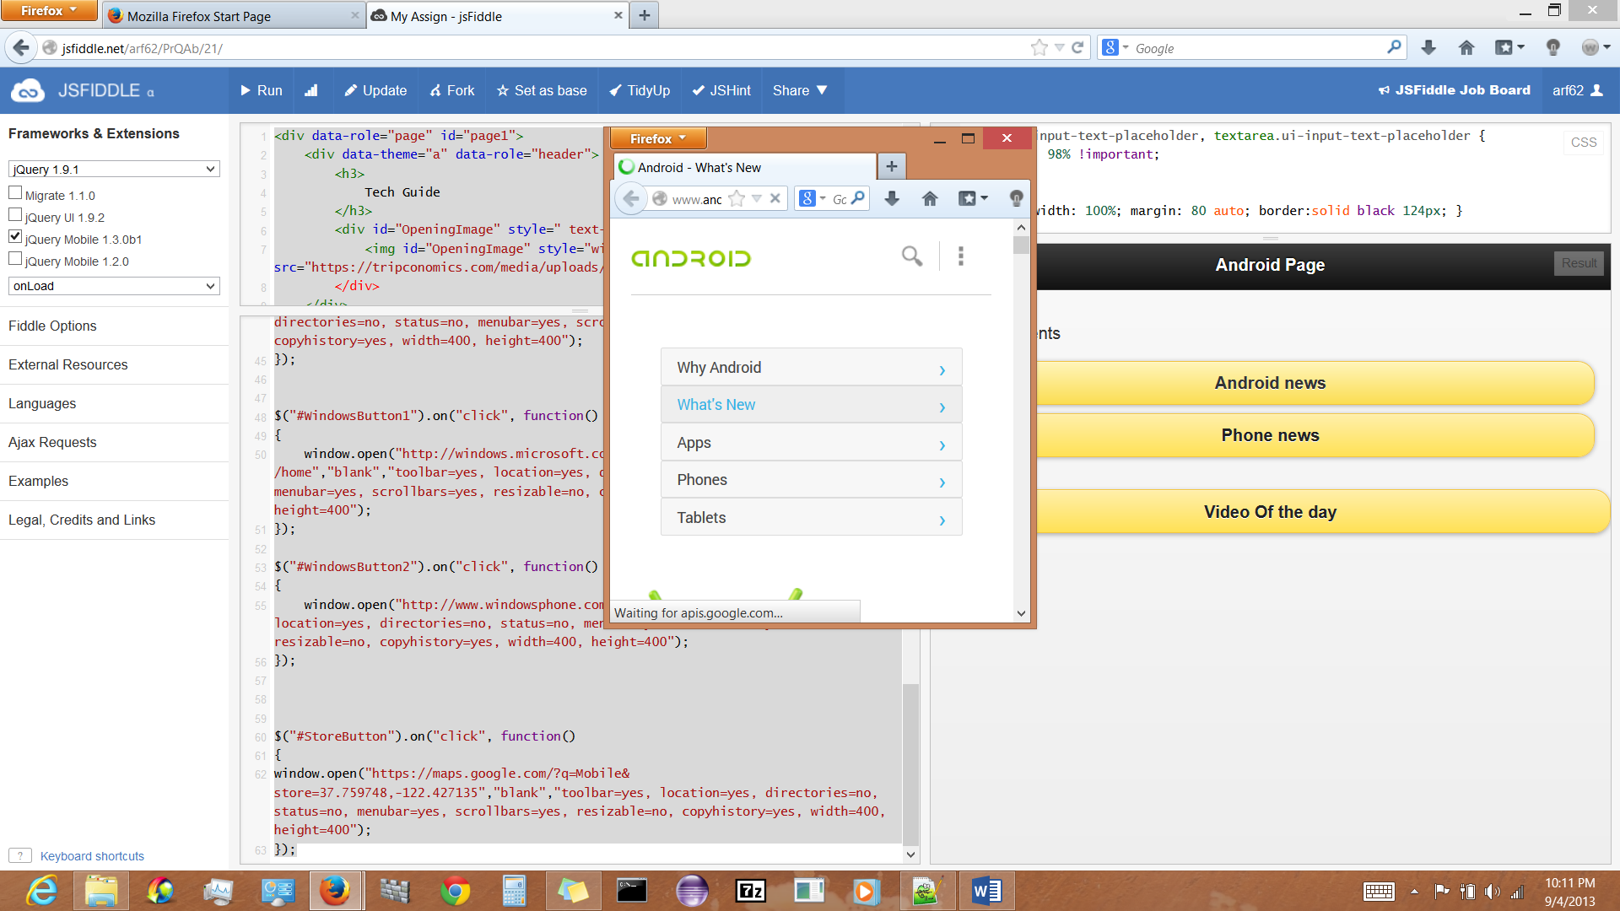  
The below screen shot shows the pop up window which comes up when user clicks on the “Android news ” button

As shown in the below screen shot a pop up mew comes up when the user clicks on the “phone news” button. User can select any of the phones and as soon as he/she does that he or she is redirected to the official page of the phone which is selected.

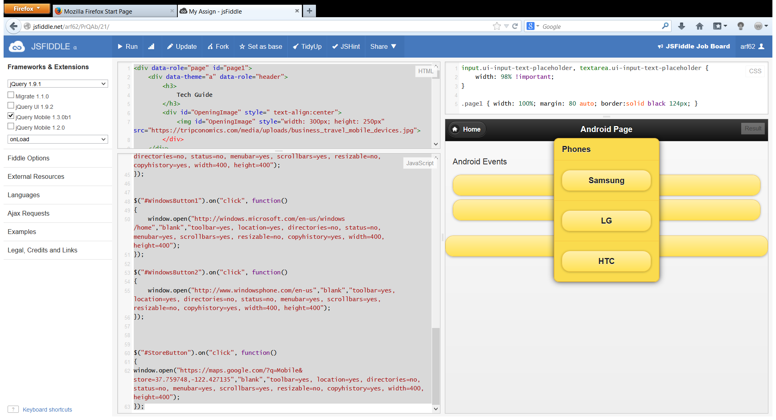

The below screen shot shows the official Samsung mobile site poping up as soon as the user clicks on the samsung button in the phones menu. 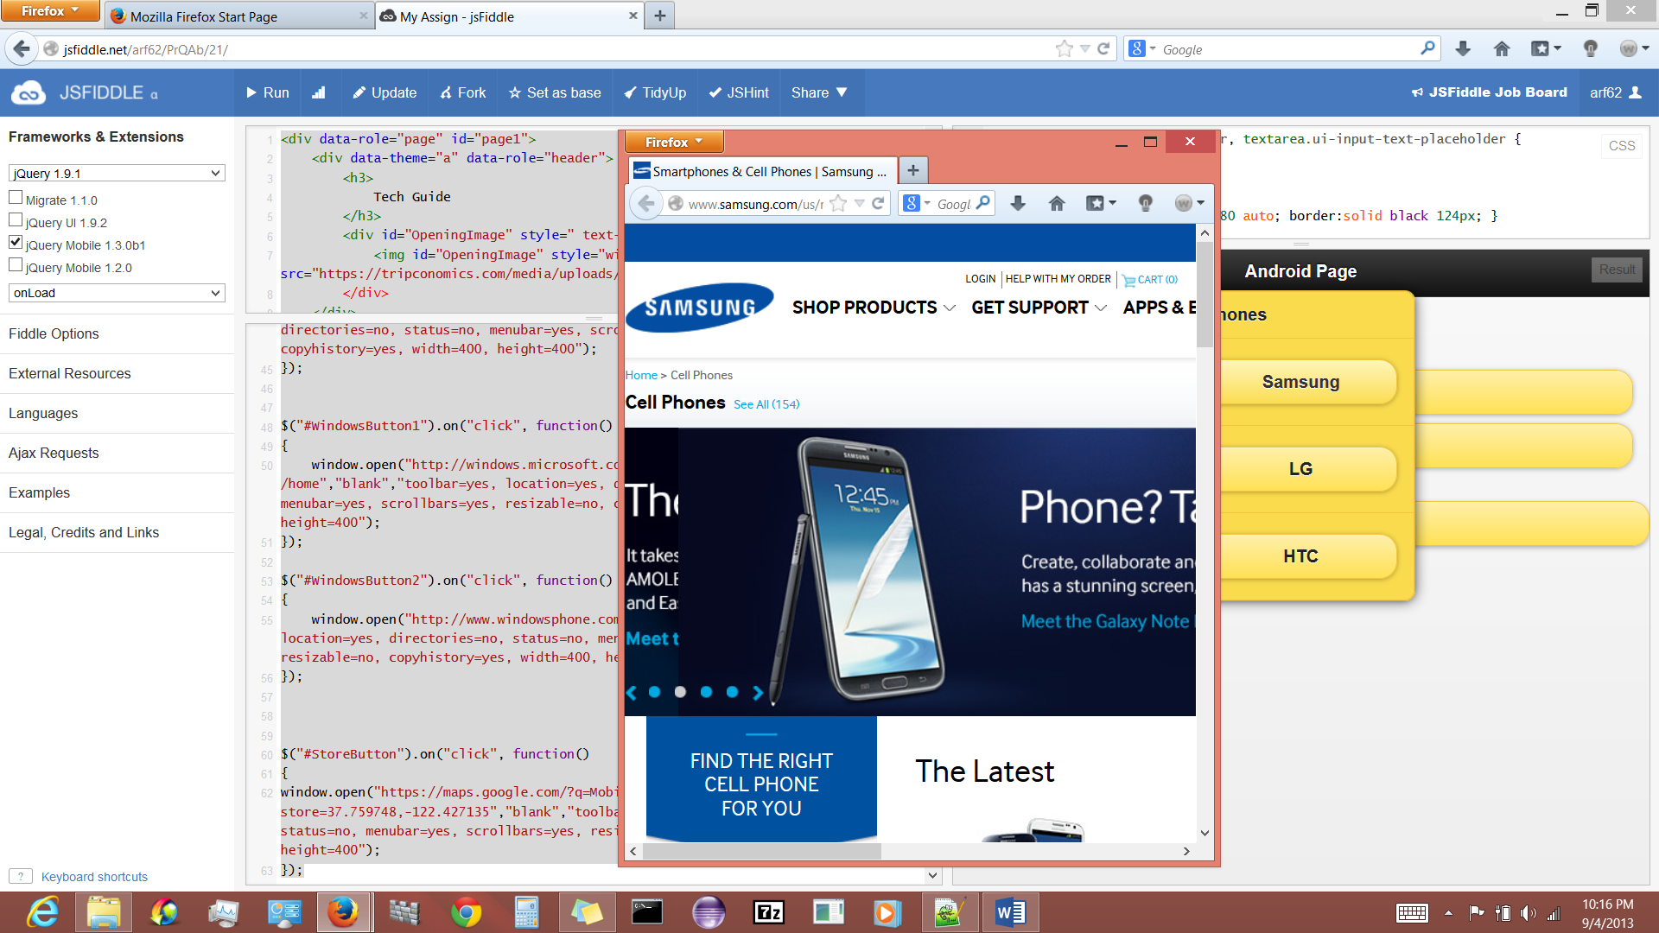

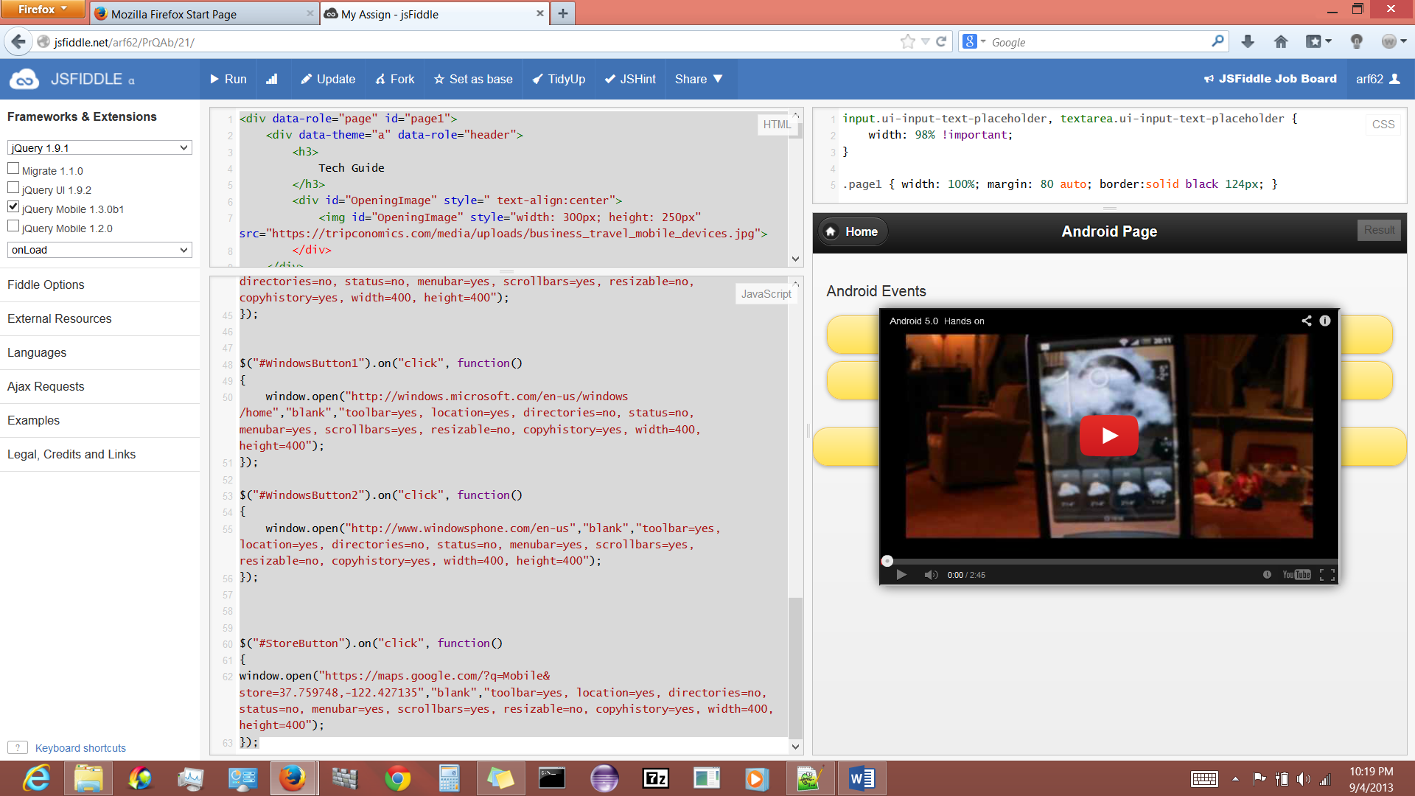

The above screen shows the video of the day popping up when the user clicks on the “video of the day button” in the android section.

The functionalities of the rest of the technologies are also similar to Android, hence skipping over them and showing the google maps functionality.

The below screen shot shows how the google map pops up when the user clicks on the “Find A store” button.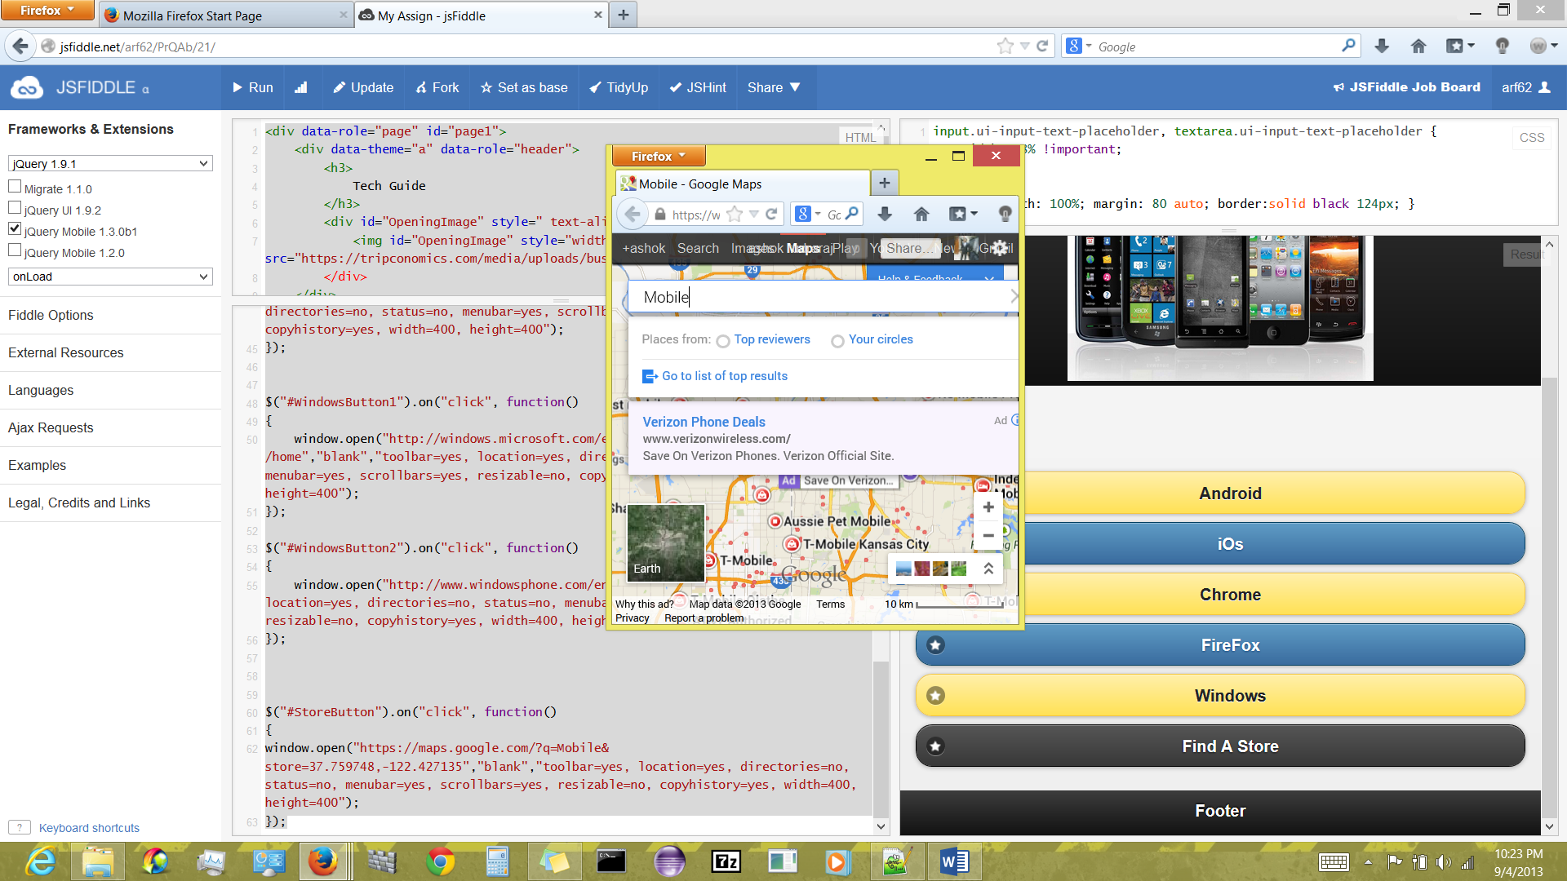

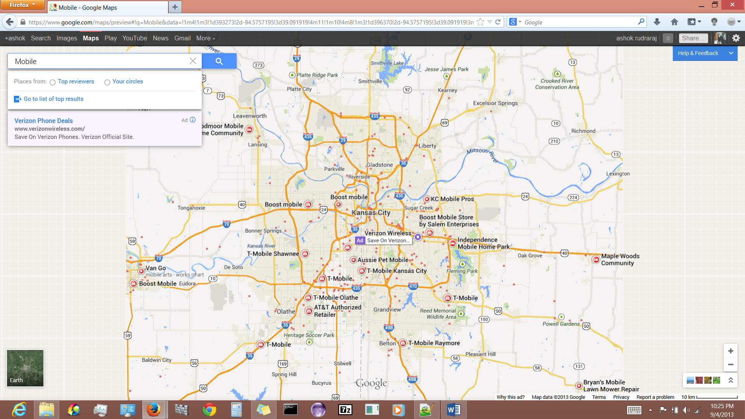

References:

Wikipedia

w3schools

jquerymobile.com

codiqa

google images